Framework description: Before I proceed further with my framework, firstly let me elaborate about the components which are using in our framework. These are:

1. **Maven Project:** We have maintained our framework in maven project in order to utilize the facilities provided by maven such as project management structure and dependencies.
2. **TestNg:** Next component is TestNG testing framework which is being primarily used to test execution engine to control our automation test execution such as parallel execution, grouping of test scripts such as regression, smoke or functional scripts, passing the required test parameters etc.
3. **Page Object model:** Next component is page object model to segregate the test code and page specific code such as locators defined in page classes and reduce code maintenance efforts and code duplication.
4. **Jenkins:** A tool to create different Jenkins batch jobs to bring CI into our project. (17th Sep ’18 ) – We have the following three jobs in Jenkins

**4.1 Docker start job: This job has been configured with Docker runner batch file. This batch contains commands to start the Docker grid by having commands to start hub, linking the chrome and Firefox nodes. This step can also be explained with ‘docker-compose’ .yml file as well.**

**4.2 Script running job:** we have another job aligned with git by having various maven goals such as **mvn compile and test.** This job is set at run at every morning at 5 a.m.

**4.3 Docker down job: This job has been configured with Docker commands which shut down the Docker grid.**

1. **Git central code repository:** We have been using git as a central code repository**.** I am managing this.
2. **Grid:** This is being used to achieve multi browser testing on different machines at the same time to achieve faster execution time
3. **Extent Report:** For our reporting mechanism we are using extent report API.

Framework composition:

1. Data driven framework
2. Maven Project

* Maven is used to define project structure, dependencies, build, and test management.
* Using pom.xml(Maven) you can configure dependencies needed for building testing and running code.
* Maven automatically downloads the necessary files from the repository while building the project.

1. Page object model:

* Page Object Model is a design pattern to create Object Repository for web UI elements.
* Under this model, for each web page in the application there should be corresponding page class.
* This Page class will find the WebElements of that web page and also contains Page methods which perform operations on those WebElements.
* Name of these methods should be given as per the task they are performing i.e., if a loader is waiting for payment gateway to be appear, POM method name can be waitForPaymentScreenDisplay().

1. Testng—as a testing framework or execution engine: Mainly for grouping of testing [smoke, regression, sweep etc.]and parallel execution, no main method to run the test, to use the inbuilt assertions
2. Jenkins: As a CI tool: It fires pre-configured actions when a particular step occurs in jobs. To run the framework at 5: am every day.

**Usage in our framework:**

* Jenkins provides direct links to the latest build or failed build that can be used for easy communication.
* TestNG test: Jenkins can be configured to run the automation test build on TestNG

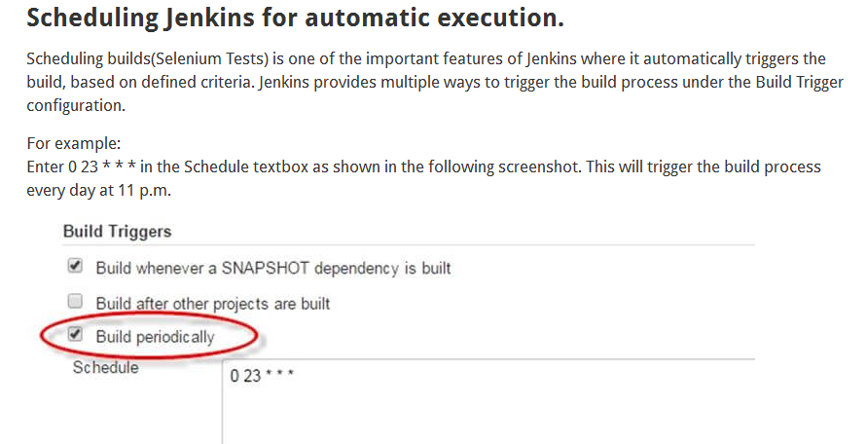

1. Grid: for multi browser testing on different machines at the same time to achieve faster execution time

To design test scripts that will run on the grid, we need to use DesiredCapabilites and the RemoteWebDriver objects.

* DesiredCapabilites is used to set the type of browser and OS that we will automate
* RemoteWebDriver is used to set which node (or machine) that our test will run against.

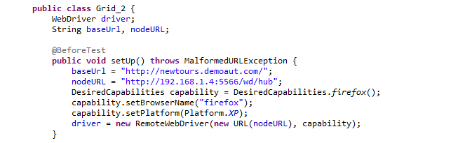

1. Git
2. Reporting: Extent report

Framework components: Following are the two main components in our framework where all the framework evolves around

My Framework:

1. src\test\java
2. Module packages: Example: All test cases related with Application Home page

🡪Test Cases: Below are the components of particular test class (as a test case)

@ Before method🡪 Initializing excels, Checking Skipping or not skipping suite utility etc., and initialization report for Extent report on the basis of browser.

Inside before, we used to call basesetUp method which is being used to initialize remote webdriver set up such as for chrome or Firefox based on the parameters passed from testng xml.

@Test🡪Test Steps: Inside this method, various methods were called as a part of test step from related page class. For example: Verify home page logo function to verify the logo on the home page.

@ After Method: ITestResult (Success, failure, skipping etc.), Writing to excel report, closing and flushing extent report based on the browsers, quitting web driver instance.

1. Listeners: Customized listeners
   1. Suite listener: OnStart, onFinish etc. E.g. Extent report initialization and flushing and excel report object initialization
   2. Iinvokemethod listener: Before invocation, after invocation
   3. TestListner adapter: OnTestFinish,OnTestSuccess
2. src\main\java:
   1. Packages: BaseSetup: Contains general code which is common to all classes and used by them.
      1. BaseSetUp class: Initiation of excels, Initialization of browser from testng xml, desired capabilities and main extent report instance initialization
      2. Config reader package,
      3. Package for alerts,
   2. Page Packages: E.g. Home page package: Contain all the pages for home page and its objects and locators and its related processing methods.
   3. Utility classes:
      * 1. Application utility lib: Generic methods specific to application e.g. selectfromdropdown, selectdesiredcheckboxes, fetchGridData, verifyGridRowdata etc.
        2. Generic utility lib: wrapper generic functions such as kendo calener selection, click, type, wait for element, selectcheckbox,isclickable, iselementpresent
        3. Java script utility class
        4. Wait, alert and drop down utility classes.
   4. dataproviderRepository: Getting login data, configuration data etc.
   5. ExcelReader
   6. Resoruces: e.g. excel data files, servers and properties files etc.
3. One testng master xml consisting of three different xml for browses and smoke and sanity. Manually remove the xml name means which phase (sanity or smoke).